SUPPORT GROUPS
INVERNESS

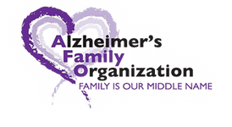ALZHEIMER’S AND DEMENTIA
SUPPORT GROUP
People touched by this disease or other related memory disorders come together in a non-judgmental, safe environment to discuss frustrations and share coping techniques.
Cornerstone Baptist Church, 1100 W. Highland Blvd. Inverness

FREE AND OPEN TO THE PUBLIC
April 15th-10:30am
May 20th-10:30am
June 24th-1:30pm
July 22nd-1:30pm
August 26th-1:30pm

Support group leader: Debbie Selsavage
For more information call
352-422-3663 or
Email:debselsavage@yahoo.com

