SUPPORT GROUPS
CRYSTAL RIVER
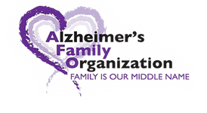
ALZHEIMER’S AND DEMENTIA
SUPPORT GROUP
People touched by this disease or other related memory disorders come together in a non-judgmental, safe environment to discuss frustrations and share coping techniques.
Crystal River Library, 8619 W. Crystal Street
FREE AND OPEN TO THE PUBLIC

April 14th-1:30pm
May 12th-1:30pm
June 9th-10:30am
July 8th-1:30pm
August 11th-1:30pm
September 8th-1:30pm
October 13th-1:30pm
November 10th-1:30pm
December 8th-1:30pm

Support group leader: Debbie Selsavage
For more information call
352-422-3663 or
Email:debselsavage@yahoo.com

