ABC of Dementia
a FREE Alzheimer’s and dementia awareness and care-giving workshop

Presented by Debbie Selsavage, President of Coping with Dementia LLC
1:30 to 3:00 p.m. February 5, 2017
Hosted by St. Margaret’s Episcopal Church
114 N. Osceola Ave, Inverness, FL
What are “Alzheimer’s” and “dementia?”
What can you expect of this progressive disease?
How can you become a better care-giver?
How do you reduce your own stress?
What are some of the resources available to you?
Each participant will receive a take-away handbook.
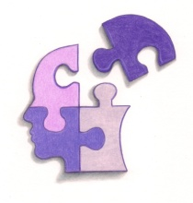
Coping with Dementia LLC
www.coping.today
deb@coping.today

R.S.V.P Debbie 352-422-3663

