ABC of Dementia
a FREE Alzheimer’s and dementia awareness and care-giving workshop

Presented by Debbie Selsavage, President of Coping with Dementia LLC
With a special presentation
by Katrina Butler from Meridien Research
10:00 to 12:00 p.m. Feb. 11, 2017
Good Shepherd Lutheran Church
439 E Norvell Bryant Hwy, Hernando, FL
What are “Alzheimer’s” and “dementia?”
What can you expect of this progressive disease?
How can you become a better care-giver?
How do you reduce your own stress?
What are some of the resources available to you?
Each participant will receive a take-away handouts.
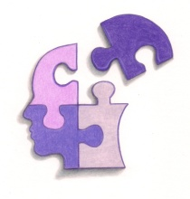 Coping with Dementia LLC
www.coping.today
deb@coping.today

R.S.V.P Debbie Selsavage 352-422-3663

