FREE Alzheimer’s and dementia awareness and care-giving workshop
Presented by: Debbie Selsavage, President, Coping with Dementia LLC
10:30 to 12:30 p.m. May 9, 2018
Lake Regions Library
1511 Druid Rd., Inverness, FL 34452
What are “Alzheimer’s” and “dementia?”
What can you expect of this progressive disease?
How can you become a better care-giver?
How do you reduce your own stress?
What are some of the resources available to you?
Each participant will receive a take-away handout.
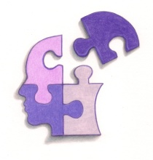
Coping with Dementia LLC
www.coping.today
deb@coping.today

R.S.V.P Debbie Selsavage 352-422-3663
“We All Deserve The Best”

