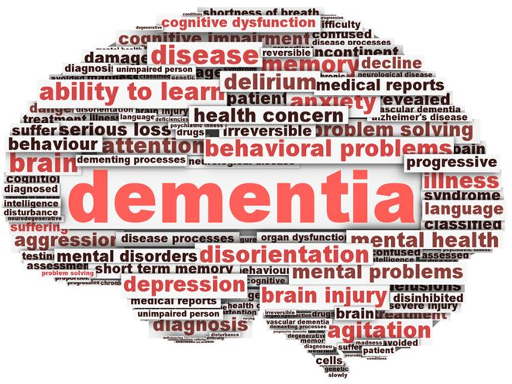
2nd Annual Coping with Dementia Conference for Caregivers
and Families
9:30 a.m. to 2:30 p.m.
September 15, 2015
Cornerstone Baptist Church
1100 W. Highland Blvd., Inverness, FL
*Experts to speak to you in clear, layman’s terms.
*Where to get help for the caregiver in Citrus County.
*Guidance on how to cope with your care-giving task.
*Meet and share with other caregivers.
*Panel discussion to answer all your questions.
*Light lunch will be provided.
*Free and open to the public
RSVP is required call Debbie at 352-422-3663
or e-mail deb@coping.today

